The Mizuho Securities Asia Limited

Azure Data Analytics Platform

Deployment Guide

Date 2 December 2024

Issued By Eastech Systems Limited

1. Data Factory Deployment
   1. Resources
   2. Export Procedure
   3. Deployment Procedure
2. Synapse Dedicated SQL Pool Deployment
   1. Resources
   2. Export Procedure
   3. Deployment Procedure
3. SSRS Report Template Deployment
   1. Resources

Paginated report

* 1. Deployment Procedure

1. Connect to UAT report server in the Report Builder

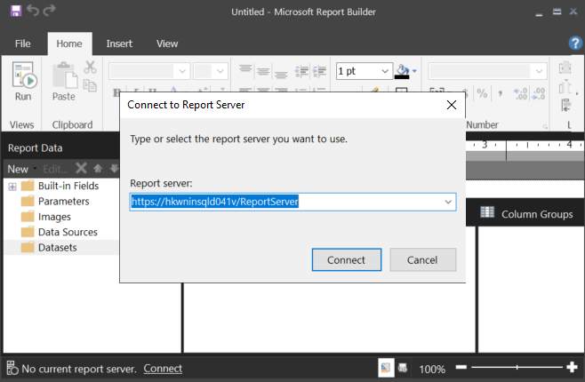

1. Click on “File” from the menu bar and then click on “Open”

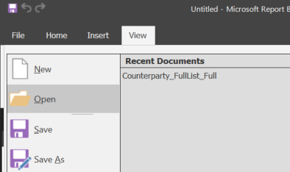

1. Select the paginated report from the UAT report server and then click on “Open”

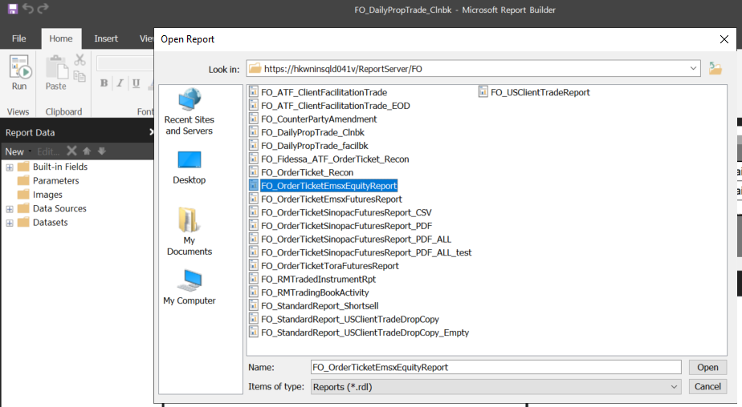

1. Click on “File” and then choose “Save as”

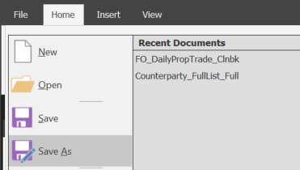

1. Select the Production server from “Recent Sites and Servers”, choose the corresponding folder for the report template, and then “Save”

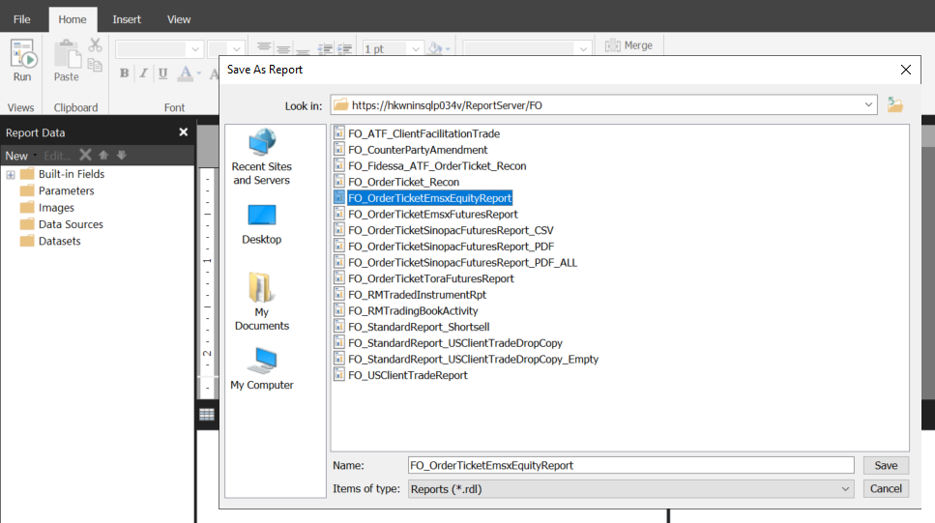

1. SSRS Report Subscription Deployment
   1. Resources

Report Subscriptions and Configurations

* 1. Export Procedure

1. Remote to the UAT Report Server

Service Account: app_hk_pbidev_adm

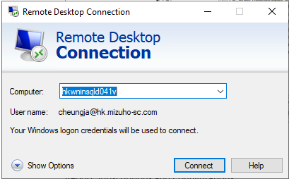

1. Open Windows PowerShell

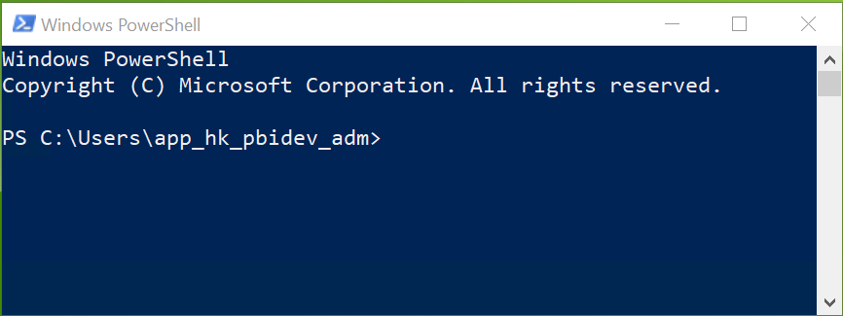

1. Execute below command: Set-ExecutionPolicy -Scope Process -ExecutionPolicy Bypass
2. Enter “Y”
3. Load module: Import-Module ReportingServicesTools
4. Export the XML:

Get-RsSubscription -ReportServerUri 'https://hkwninsqld041v/ReportServer' -RsItem '/FO_OrderTicketEMSXEquityReport ' | Export-RsSubscriptionXml 'C:\Temp\Data Driven Subscription\Deployment Round 3\FO_OrderTicketEMSXEquityReport.xml'

1. The XML should be generated in the target folder

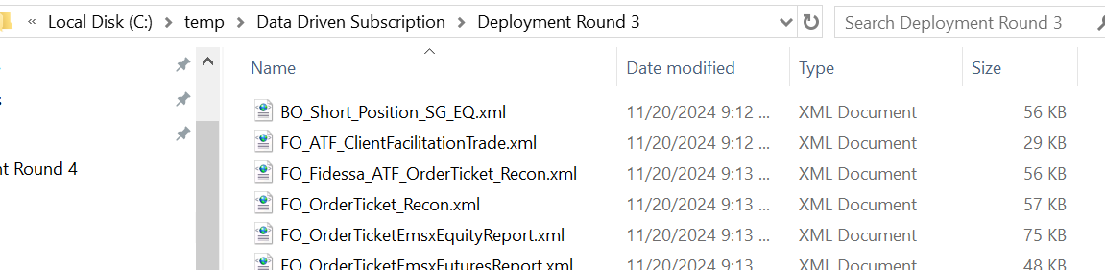

* 1. Deployment Procedure

1. Remote to the Production report server

Service Account: app_hk_pbiprd_adm

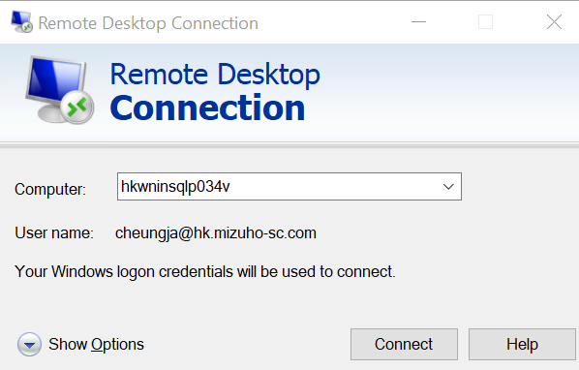

1. Copy the exported XML from UAT report server to the Production report server

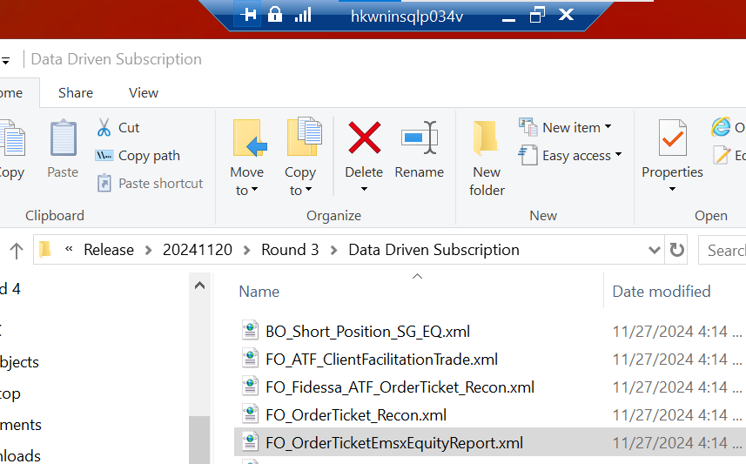

1. Open Windows PowerShell
2. Execute below command: Set-ExecutionPolicy -Scope Process -ExecutionPolicy Bypass
3. Enter “Y”
4. Load module: Import-Module ReportingServicesTools
5. Import the XML:

Import-RsSubscriptionXml 'D:\Release\20241120\Round 3\Data Driven Subscription\FO_OrderTicketEmsxEquityReport.xml' -ReportServerUri 'https://hkwninsqlp034v/ReportServer' | Copy-RsSubscription -ReportServerUri 'https://hkwninsqlp034v/ReportServer' -RsItem '/FO/FO_OrderTicketEmsxEquityReport'

1. The subscription should be created in the Production report

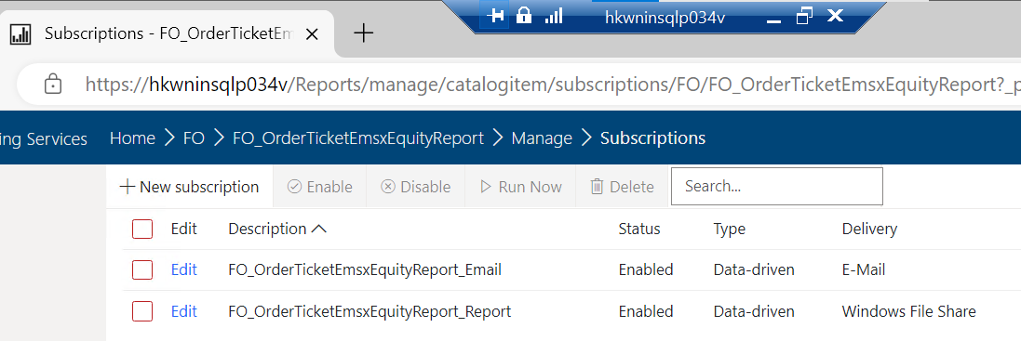

1. RMJ Process Deployment
   1. Resources

RMJ Process Definition

RMJ Chain Definition

* 1. Deployment Procedure (Promote RMJ Definitions to Test environment)

1. Go to the RMJ dev URL: <https://sydney.runmyjobs.cloud/mizuho-financial-group/dev/>
2. Open the Process Definitions and Chain Definitions tabs.

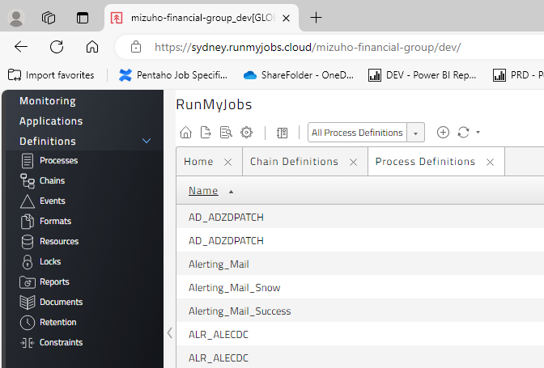

1. On the Process Definition tab, search the process name.

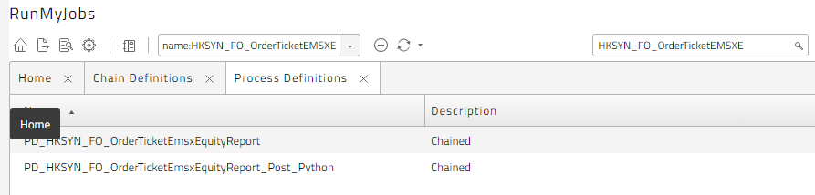

1. Right click on each process, “Promote” => Promote to system

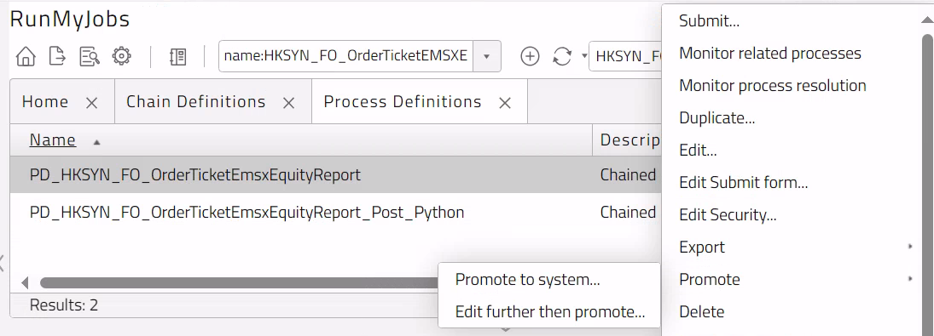

1. Check Test, click “OK”.

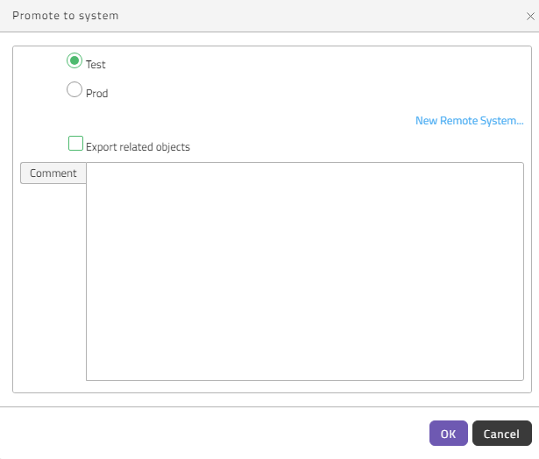

1. A message would be displayed after promoting to Test.

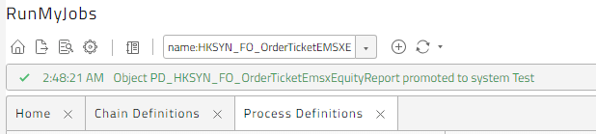

1. Repeat the above process for other processes.
2. The chain definition can only be promoted after all of the processes in the chain being promoted

Update Parameter Values in Test

1. Go to the RMJ Test URL: <https://sydney.runmyjobs.cloud/mizuho-financial-group/test/>
2. Open the Process Definitions and Chain Definitions tabs
3. To modify the parameters of a process, right click on the process => “Edit”.

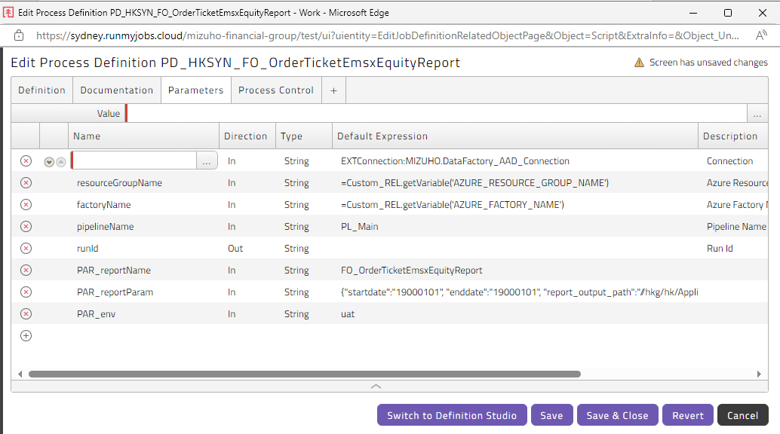

1. Update the report output path from the PAR_reportParam to the corresponding PROD path.
2. Update the email recipient, cc, bcc from the PAR_reportParam
3. Update PAR_env, “uat” => “prd”
4. Click “Save & Close”.
5. For Python program, update the env parameter with “prod”

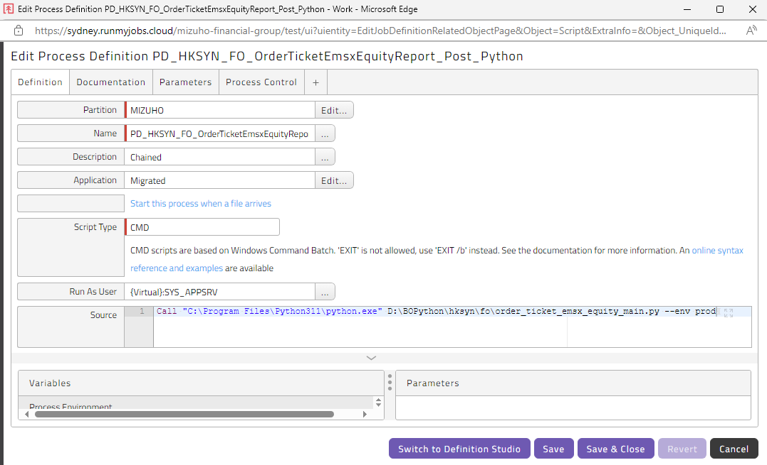

Data Analytics Platform Deployment Guide

Contents 1 Data Factory Deployment 1. Export ARM Template from UAT 2. Import ARM Template to PROD 2.2 Synapse Dedicated SQL Pool Deployment 1. Script Generation 2. Script Execution 2.3 SSRS Report Template Deployment 1. Open Report Template from UAT 2. Save the Report Template to PROD 2.4 SSRS Report Subscription Deployment with ReportingServicesTool 1. Export Report Subscription from UAT 2. Import Report Subscription to PROD 2.5 RMJ Scheduler Deployment 1. Promote to Test environment 2. Update RMJ Jobs in Test environment 3. Troubleshooting 3.1 RMJ Alert 3.2 Data Factory Monitor 3.3 Stored Procedure Log 3.4 SSRS Report Server Log

1. Introduction 1.1 Purpose The purpose of this deployment guide is to describe in technical terms the steps necessary to deploy a paginated report in the Azure Data Analytics Platform and make the report generated automated with RMJ.

1.2 Revision history Document Version 1st Draft | 2nd Dec, 2024 | Eastech

1.3 Signoffs

1.4 Intended audience and reading suggestions. This Deployment Guide is intended to be used by technical stakeholders of the project who will be responsible for support and deployment.

1.5 Technical project stakeholders Name-Email Address-Role

1.6 References